#1) Bug Number/id: 1.4
#2) Bug Title: PROD: obuvki.bg: Missing one letter in the title of the logo
#3) Priority: Low
#4) Severity: Low
#5) Test URL: https://obuvki.bg
#6) Platform: Web
#7)Browser: Chrome
#8)OS: Windows
#9) Resolution: 1366×768
#10) Environment: Production
#11) Test data:
#12) Description: Missing one letter in the title of the logo
#13) Steps to Reproduce:
1. Open website
2. Go to the logo of the website in the left side of the header
3. Hover your mouse over the logo

#14) Actual Result: The below bold text in Bulgarian language appear

амски, мъжки и детски обувки • Чанти и аксесоари – obuvki.bg

#15) Expected Result: The below bold text in Bulgarian language should appear

дамски, мъжки и детски обувки • Чанти и аксесоари - obuvki.bg

#16) Screenshot:
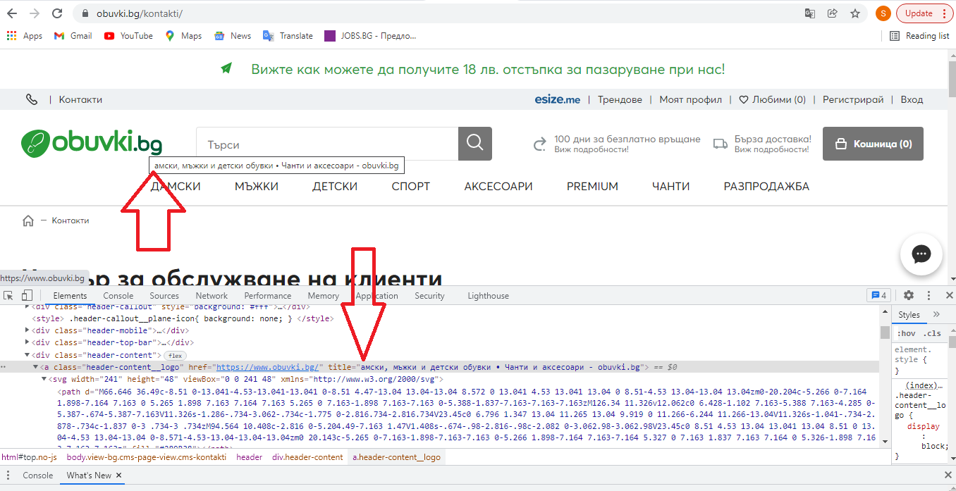

#1) Bug Number/id: 1.5
#2) Bug Title: PROD: obuvki.bg: Phone Icon is not working
#3) Priority: Medium
#4) Severity: Low
#5) Test URL: https://obuvki.bg
#6) Platform: Web
#7)Browser: Chrome
#8)OS: Windows
#9) Resolution: 1366×768
#10) Environment: Production
#11) Test data:
#12) Description: Phone Icon is not working
#13) Steps to Reproduce:
1. Open website
2. Go to top left corner of the website, over the logo in the header
3. Press the Phone Icon

#14) Actual Result: Nothing happens, the number is not entered automatically for dialling in skype

#15) Expected Result: The system should ask you to choose a program to dial the number and when you choose for example skype the number should be entered automatically for dialling in skype

#16) Screenshot:
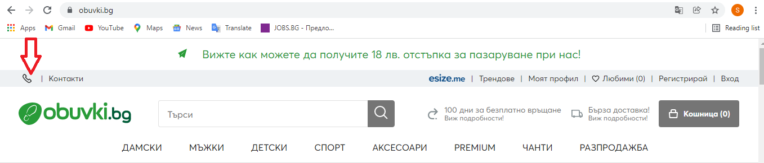

#1) Bug Number/id: 2.5
#2) Bug Title: PROD: obuvki.bg: Confirmation text is written in English
#3) Priority: Medium
#4) Severity: Low
#5) Test URL: https://obuvki.bg
#6) Platform: Web
#7)Browser: Chrome
#8)OS: Windows
#9) Resolution: 1366×768
#10) Environment: Production
#11) Test data:
- email: test6@gmail.com
#12) Description: The text for confirmation in the green field at top of the page is written in English
#13) Steps to Reproduce:
1. Open website
2. Go to top of the page
3. Press the pop up text “ Вижте как можете да получите 18 лв. отстъпка за пазаруване при нас!”
4. In the text field enter valid email address
5. Press the button “Абонирайте се”

#14) Actual Result: The text for confirmation in the green field at top of the page is written in English

#15) Expected Result: The confirmation text in green field at top of the page should be written in Bulgarian language

#16) Screenshot:
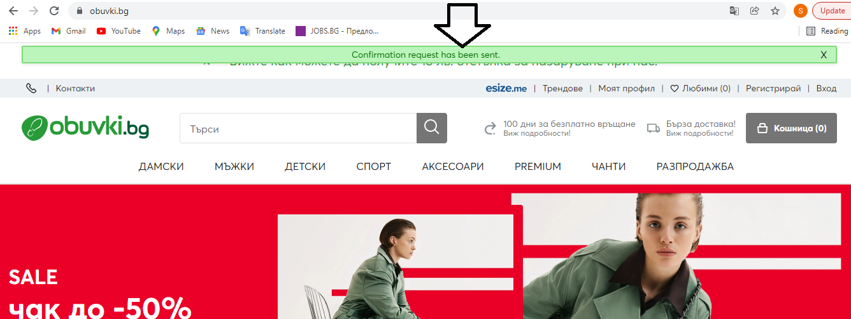

#1) Bug Number/id: 2.6
#2) Bug Title: PROD: obuvki.bg: Information text is written in English
#3) Priority: Medium
#4) Severity: Low
#5) Test URL: https://obuvki.bg
#6) Platform: Web
#7)Browser: Chrome
#8)OS: Windows
#9) Resolution: 1366×768
#10) Environment: Production
#11) Test data:
- email: test6@gmail.com
#12) Description: The text for information about that this email is already registered in the red field at top of the page is written in English
#13) Steps to Reproduce:
1. Open website
2. Go to top of the page
3. Press the pop up text “ Вижте как можете да получите 18 лв. отстъпка за пазаруване при нас!”
4. In the text field enter valid email address
5. Press the button “Абонирайте се”
#14) Actual Result: The text for information about that this email is already registered in the red field at top of the page is written in English
#15) Expected Result: The information about that this email is already registered in the red field at top of the page should be written in Bulgarian language
#16) Screenshot:
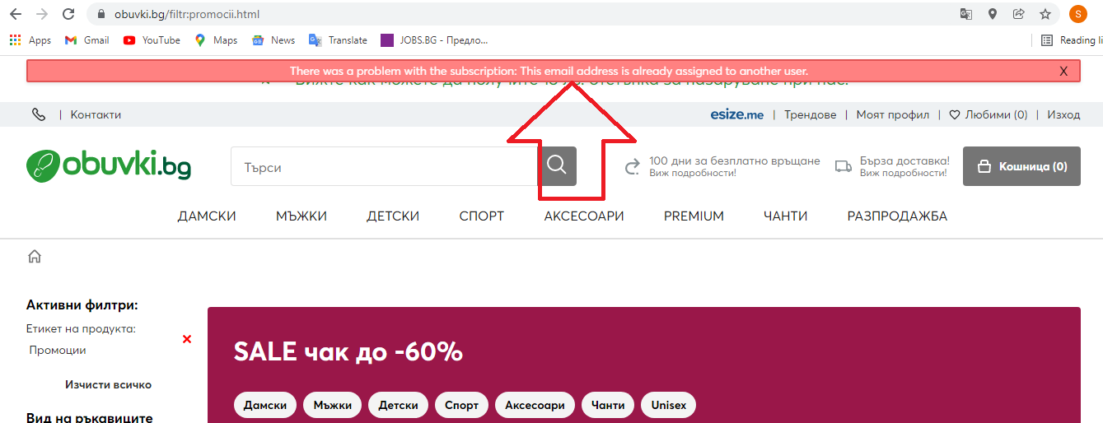

#1) Bug Number/id: 4.7
#2) Bug Title: PROD: https://www.obuvki.bg/esizeme: Google Play Store wrong redirection
#3) Priority: Medium
#4) Severity: Low
#5) Test URL: https://www.obuvki.bg/esizeme
#6) Platform: Web
#7)Browser: Chrome
#8)OS: Windows
#9) Resolution: 1366×768
#10) Environment: Production
#11) Test data:
#12) Description: Image button for Google Play Store is redirecting to Apple App Store
#13) Steps to Reproduce:
1. Open the Test URL
2. Scroll down to image button “Google Play”
3. Click “Google Play” image button

#14) Actual Result: The website is redirecting to Apple App Store

#15) Expected Result: In the same browser tab you should be redirected to Google Play Store to download the app

#16) Screenshot:
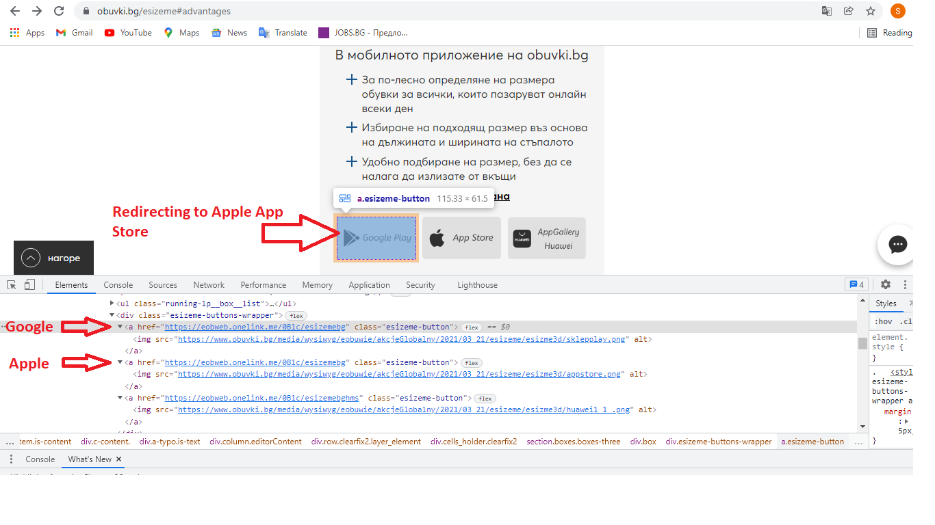
#1) Bug Number/id: 4.9
#2) Bug Title: PROD: https://www.obuvki.bg/esizeme: AppGallery Huawei wrong redirection
#3) Priority: Medium
#4) Severity: Low
#5) Test URL: https://www.obuvki.bg/esizeme
#6) Platform: Web
#7)Browser: Chrome
#8)OS: Windows
#9) Resolution: 1366×768
#10) Environment: Production
#11) Test data:
#12) Description: Image button for AppGallery Huawei is redirecting to Apple App Store
#13) Steps to Reproduce:
1. Open the Test URL
2. Scroll down to image button “AppGallery Huawei”
3. Click “AppGallery Huawei” image button

#14) Actual Result: The website is redirecting to Apple App Store

#15) Expected Result: In the same browser tab you should be redirected to AppGallery Huawei to download the app

#16) Screenshot:
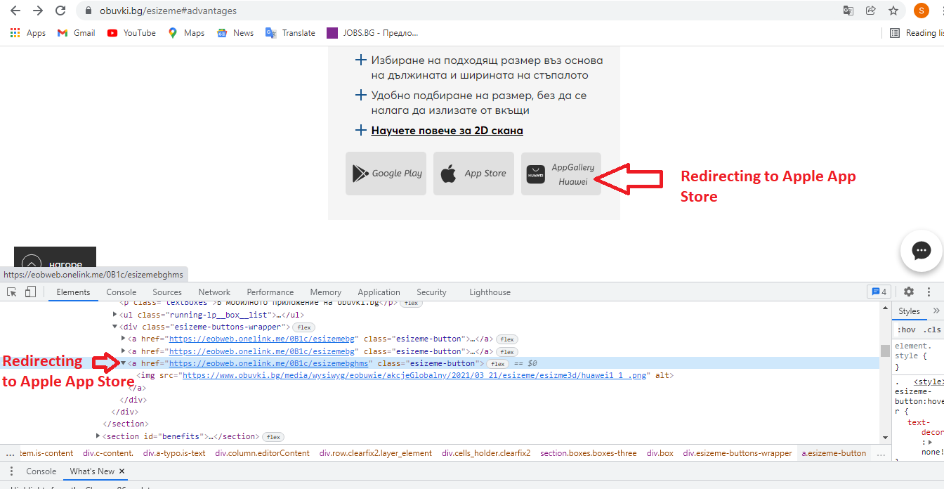

#1) Bug Number/id: 4.10
#2) Bug Title: PROD: https://www.obuvki.bg/esizeme: Text written in inappropriate format
#3) Priority: Low
#4) Severity: Low
#5) Test URL: https://www.obuvki.bg/esizeme
#6) Platform: Web
#7)Browser: Chrome
#8)OS: Windows
#9) Resolution: 1366×768
#10) Environment: Production
#11) Test data:
#12) Description: Under the image there is text “do nas!” written in inappropriate format
#13) Steps to Reproduce:
1. Open the Target URL
2. Search for text “do nas!” positioned to the left bottom corner under the image next to text “Оценявайте нашите препоръки”

#14) Actual Result: Under the image there is text “do nas!” written in inappropriate format

#15) Expected Result: Under the image there should not be any text written in inappropriate format

#16) Screenshot:
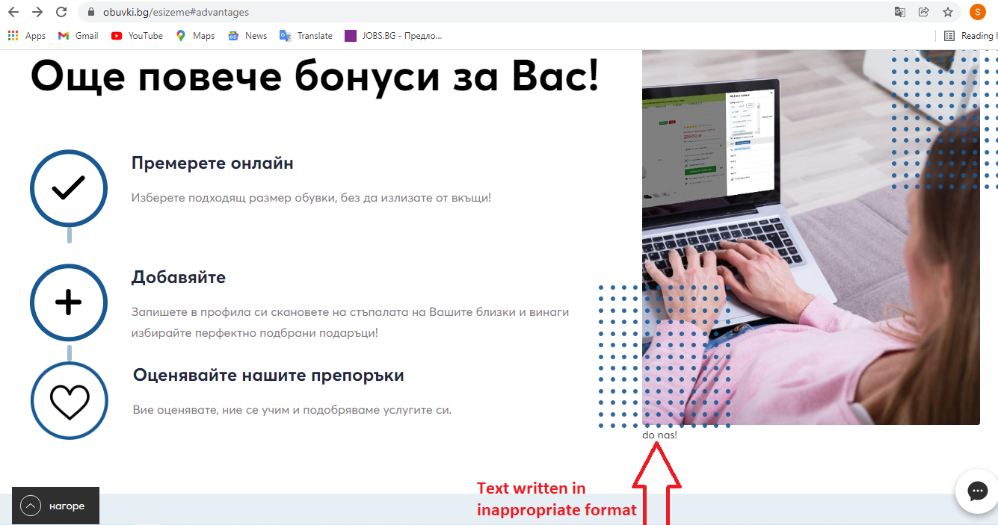

#1) Bug Number/id: 6.7
#2) Bug Title: PROD: https://www.obuvki.bg/newsletter/manage: Confirmation text is written in English
#3) Priority: Medium
#4) Severity: Low
#5) Test URL: https://www.obuvki.bg/newsletter/manage
#6) Platform: Web
#7)Browser: Chrome
#8)OS: Windows
#9) Resolution: 1366×768
#10) Environment: Production
#11) Test data:
1. Email: vesistoyanov@gmail.com
2. Password: 123qwe

#12) Description: The text for confirmation in the green field at top of the page is written in English
#13) Steps to Reproduce:
1. Open the Target URL
2. In the first field in the left part of the page enter your email address given in Test Data
3. In the second field in the left part of the page enter your password given in Test Data
4. Click green button “Вход”
5. Click link “Абонаменти за бюлетин” positioned in the left of the page in the horizontal menu
6. Check the checkbox “Общ бюлетин”
7. Click on green button “Запис”

#14) Actual Result: The text for confirmation in the green field at top of the page is written in English
#15) Expected Result: The confirmation text in green field at top of the page should be written in Bulgarian language
#16) Screenshot:
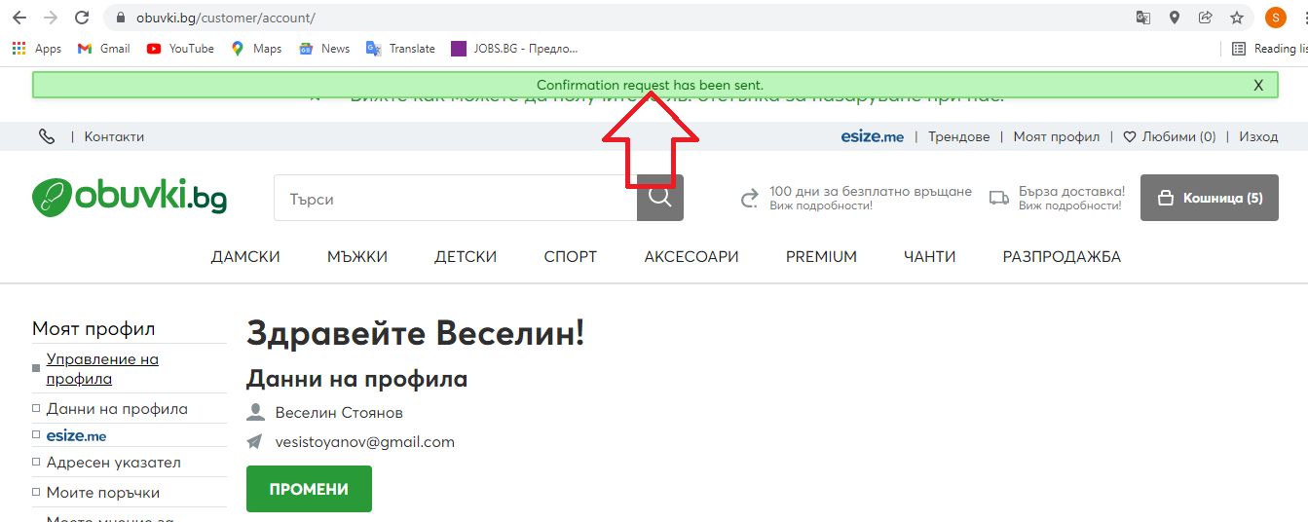
#1) Bug Number/id: 8.5
#2) Bug Title: PROD: obuvki.bg: Confirmation text is written in English
#3) Priority: Medium
#4) Severity: Low
#5) Test URL: https://obuvki.bg
#6) Platform: Web
#7)Browser: Chrome
#8)OS: Windows
#9) Resolution: 1366×768
#10) Environment: Production
#11) Test data:
1. Name – Vesselin
2. Last name – Stoyanov
3. Email – test8@gmail.com
4. Password – 123qwe
#12) Description: The text for confirmation in the green field at top of the page is written in English
#13) Steps to Reproduce:
1. Open the Target URL
2. Fill the first field with your name
3. Fill the second field with your last name
4. Fill the third field with your email address
5. Fill the fourth field with your password
6. Fill the fifth field with your password for confirmation
7. Check the first checkbox
8. Check the second checkbox
9. Click on the button “Регистрация”

#14) Actual Result: The text for confirmation in the green field at top of the page is written in English

#15) Expected Result: The confirmation text in green field at top of the page should be written in Bulgarian language

#16) Screenshot:
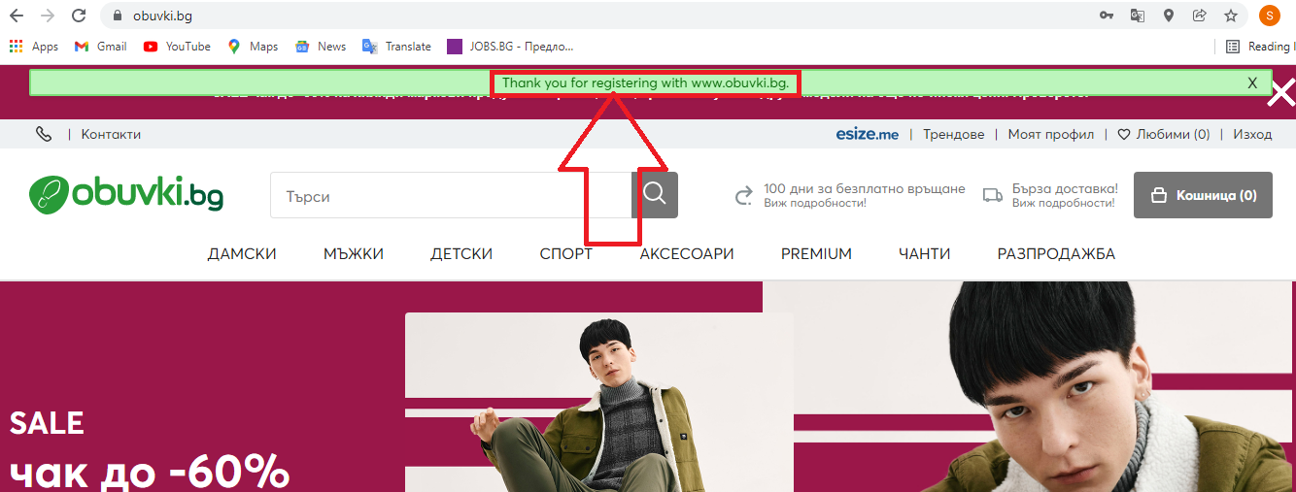
#1) Bug Number/id: 11.12
#2) Bug Title: PROD: https://www.obuvki.bg/kak-da-pazaruvame :Page don’t exist
#3) Priority: High
#4) Severity: Medium
#5) Test URL: https://www.obuvki.bg/kak-da-pazaruvame
#6) Platform: Web
#7)Browser: Chrome
#8)OS: Windows
#9) Resolution: 1366×768
#10) Environment: Production
#11) Test data:
#12) Description: Page don’t exist with error 404
#13) Steps to Reproduce:
1. Open homepage
2. Click on button “Мъжки” available in the header
3. Scroll down and click on a product
4. Scroll down and click on a green button “Добави в кошницата” positioned on the right side of the page
5. A new window will appear for size, choose size number
6. A pop up window will appear on screen with product information, click on the green button “Към касата”
7. Scroll down and click on link “Как да пазарувате?” positioned in section Имате ли въпрос за поръчката?

#14) Actual Result: A new page is opening saying that the page don’t exist with error 404
#15) Expected Result: A new page in the same browser tab should open with information about the topic
#16) Screenshot:
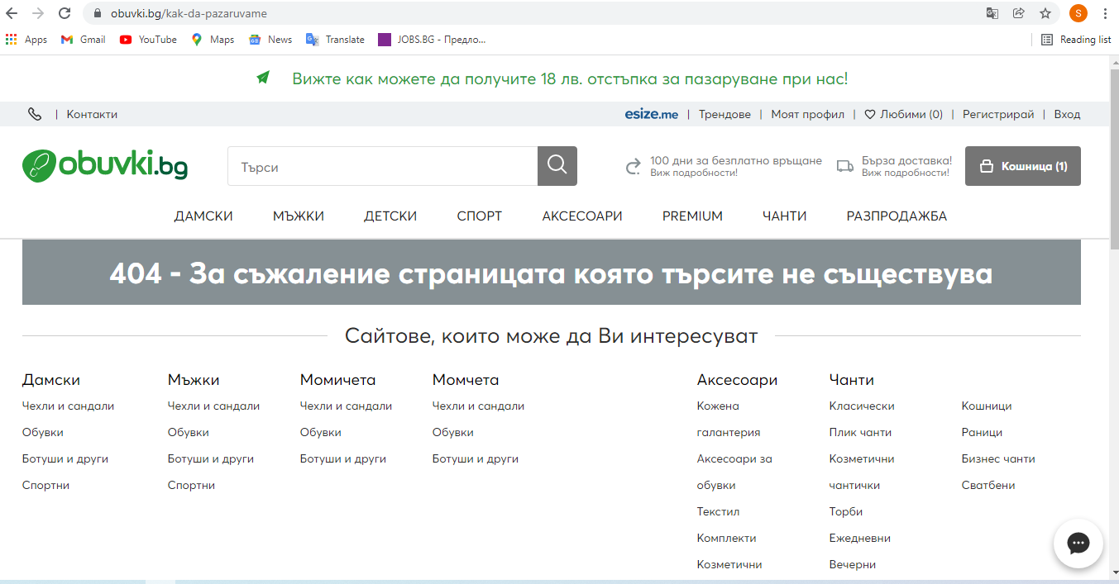
#1) Bug Number/id: 13.25
#2) Bug Title: PROD: https://www.obuvki.bg : text error
#3) Priority: Low
#4) Severity: Low
#5) Test URL: https://www.obuvki.bg
#6) Platform: Web
#7)Browser: Chrome
#8)OS: Windows
#9) Resolution: 1366×768
#10) Environment: Production
#11) Test data:
#12) Description: The link is written in Bulgarian language with English letters
#13) Steps to Reproduce:
1. Open the Target URL
2. Scroll down to link “abonament sms esize.me” positioned in the right side of the footer
#14) Actual Result: The link is written in Bulgarian language with English letters
#15) Expected Result: The link should be written in Bulgarian language
#16) Screenshot:
